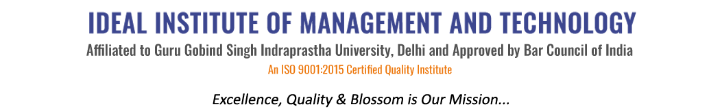
16 X, Karkardooma Institutional Area, (Near Telephone Exchange)
Delhi-110092
+91 (11) 22372639, 22375961,
http://idealinstitute.edu.in
5.1.1. Average percentage of students benefited by scholarship and freeships provided by the Government during the last five years.
Year | Name of the Scheme | Number of students benefited by government scheme | Number of students benefited by non government scheme
2016 - 2017 | EWS Scheme of GGSIPU | 05 | NIL
2016 - 2017 | Merit Scholarship  to SC/ST/OBC/ | 01 | NIL
2017 - 2018 | Merit-Cum-Means | 01 | NIL
2017 - 2018 | EWS Scheme of GGSIPU | 08 | NIL

JITENDER YADAV Prof (Dr) Anil Parkash Sharma
(NODAL OFFICER) Director, IIMT

16 X, Karkardooma Institutional Area, (Near Telephone Exchange)
Delhi-110092
+91 (11) 22372639, 22375961,
http://idealinstitute.edu.in

SC/ST/OBC/Differently Abled STUDENTS

A.S.-2013-14
S. NO. | COURSE | TOTAL NO. OF STUDENTS ENROLLED | GENERAL | SC | ST | OD | Differently Abled
1 | BBA | 60 | 56 | 4 | 0 | 5 | 0
2 | BBA(CAM) | 28 | 27 | 1 | 0 | 3 | 0
3 | BBA(EVE) | 44 | 44 | 0 | 0 | 5 | 0
4 | BBA(CAM)EVE. | 28 | 27 | 1 | 0 | 3 | 0
5 | BALLB(H) | 74 | 68 | 6 | 0 | 9 | 0
A.S.-2014-15
S. NO. | COURSE | TOTAL NO. OF STUDENTS ENROLLED | GENERAL | SC | ST | OD | Differently Abled
1 | BBA | 57 | 55 | 2 | 0 | 7 | 0
2 | BBA(CAM) | 44 | 42 | 2 | 0 | 5 | 0
3 | BBA(EVE) | 58 | 58 | 0 | 0 | 9 | 0
4 | BBA(CAM)EVE. | 39 | 39 | 0 | 0 | 3 | 0
5 | BALLB(H) | 104 | 90 | 14 | 0 | 12 | 0
A.S.-2015-16
S. NO. | COURSE | TOTAL NO. OF STUDENTS ENROLLED | GENERAL | SC | ST | OD | Differently Abled
1 | BBA | 59 | 52 | 7 | 0 | 3 | 0
2 | BBA(CAM) | 45 | 44 | 1 | 0 | 7 | 0
3 | BBA(EVE) | 60 | 56 | 4 | 0 | 10 | 0
4 | BBA(CAM)EVE. | 43 | 43 | 0 | 0 | 5 | 0
5 | BALLB(H) | 107 | 91 | 16 | 0 | 28 | 1
A.S.-2016-17
S. NO. | COURSE | TOTAL NO. OF STUDENTS ENROLLED | GENERAL | SC | ST | OD | Differently Abled
1 | BBA | 56 | 54 | 2 | 0 | 4 | 0
2 | BBA(CAM) | 43 | 43 | 0 | 0 | 3 | 0
3 | BBA(EVE) | 59 | 59 | 0 | 0 | 7 | 0
4 | BBA(CAM)EVE. | 44 | 44 | 0 | 0 | 8 | 0
5 | BALLB(H) | 105 | 98 | 7 | 0 | 25 | 0
A.S.-2017-18
S. NO. | COURSE | TOTAL NO. OF STUDENTS ENROLLED | GENERAL | SC | ST | OD | Differently Abled
1 | BBA | 60 | 58 | 2 | 0 | 9 | 0
2 | BBA(CAM) | 45 | 45 | 0 | 0 | 9 | 0
3 | BBA(EVE) | 60 | 60 | 0 | 0 | 6 | 0
4 | BBA(CAM)EVE. | 45 | 45 | 0 | 0 | 7 | 0
5 | BALLB(H) | 109 | 100 | 9 | 1 | 23 | 1

Prof (Dr) Anil Parkash Sharma
Director, IIMT

